SELF-WEIGHING DEVICE FOLLOWER SUITCASE

A PROJECT REPORT

Submitted by

Amrutha Mupparaju

Abstract
Nowadays, one of the most significant aspects of life for people is travel. The majority of people used very traditional travel bags or luggage carrier systems, which necessitates a significant amount of security-related human effort.
These days, the advancement of electronics lessens the impact of physical labor and allows for closer interaction between man and machine, which makes work smarter. The development of better safe and secure luggage carrier systems that reduce human effort and guarantee a comfortable, hand-free journey for people can be made possible by the advancements in electronics systems.
In essence, the Automated Luggage Carrier system we've proposed functions like a porter who always follows the operator. It is a hands-free load-carrying propulsion system that keeps a safe following distance from the user. The identity of the owner can guarantee the privacy of the luggage bag. GPS and GSM can be used to track the system's location.
By incorporating a variety of sensors to improve performance and broaden its application, this multipurpose suitcase—which can weigh itself and follow the user—basically uses the Internet of Things (IoT) concept.
Currently, a microcontroller, weight sensor, Bluetooth module, mobile app, ultrasonic sensor for, and infrared sensor for obstacle detection are all included in the suitcase.
Using the suitcase on stairs or uneven ground, as well as moving it through a crowded space where there may be too many users, are some of the difficulties that must be taken into account.

Keywords: Multipurpose Suitcase, Sensors, App, Microcontroller.

Table Of Contents
ACKNOWLEDGMENT | i
ABSTRACT | ii
LIST OF FIGURES
CHAPTER 1: INTRODUCTION | 1
1.1 Objective | 2
1.2 Existing System | 3
1.3 Proposed System | 3
1.4 Motivation | 4
CHAPTER 2: LITERATURE SURVEY  2.1 Literature Survey-1 | 5
2.2 Literature Survey-2 | 6
2.3 Literature Survey-3 | 7
2.4 Literature Survey-4 | 8
2.5 Literature Survey-5 | 9
2.6 Literature Survey-6 | 10
2.7 Literature Survey-7 | 11
CHAPTER 3: DESIGN AND ANALYSIS  3.1 Block diagram | 12
3.2 Flowchart of Working Model | 16
CHAPTER 4: RESULT  4.1 Result | 18
4.2 Method | 23
4.3 Conclusion | 24
4.4 References | 27
Appendix
Appendix-A Appendix-B

List of Figures
Figure 3.1 Block Diagram for Proposed System Figure 3.1.1 Block Diagram for Self-Weighing System Figure 3.1.2 Load Cell
Figure 3.1.3 Composition of Load Cell Figure 3.1.4 HX711 Amplifier
Figure 3.1.5 Block Diagram for Automatic Follow System Figure 3.1.6 Ultrasonic Sensor
Figure 3.1.7 Infrared Sensor
Figure 3.1.8 DC Battery Operated Motor Figure 3.1.9 Motor Driver
Figure 3.2.1 Flowchart for The Self Weighing System Figure 3.2.2 Flowchart for Automatic Follow System Figure 4.2.1 weighing system displaying weight of 20g stone Figure 4.2.2 weighing system displaying weight of 36g battery

List of Tables
Table 4.2 Movement of Suitcase based on presence of Obstacle on the path

Chapter 1: Introduction
When traveling, a suitcase serves as a place to store personal items. Since its creation, it has undergone numerous design modifications. The suitcase is now portable thanks to all the changes. Every time the suitcase was upgraded, it changed how it was handled, but it also exposed itself to security risks and gave the user a lot of problems.
The luggage we use today is incompatible with the modern, intelligent lifestyle we lead. Many passengers struggle to move or carry their suitcases and travel bags in airports and train stations; this is especially true for elderly and physically challenged passengers. For passengers with extra luggage or whose luggage exceeds a certain weight limit, the majority of major airlines impose additional fees.
The suitcase needs to be optimized from the inside out in order to address the aforementioned issues. To carry the luggage in an approachable manner, a new prototype should be created from scratch.
Making a suitcase capable of self-weighing will be the first step taken into consideration. A standard bathroom scale, a portable luggage scale, or a standard luggage scale that is available at the airport are the three methods of weighing luggage currently in use. For a more convenient travel experience, we suggest creating a suitcase with an integrated scale.
It can be exhausting to finish a long plane ride, especially if you're lugging your luggage through the airport. You may become extremely fatigued and slowed down by it. The elderly and physically disabled can also complete this task. Because of this, we think about the benefits of an automatic follow suitcase. This bag can accommodate all of your belongings and has many helpful features to address common airport issues.
The user should be able to fully control the movement of the suitcase so that it does not get lost while following them wherever they go.

Objective
To design a Suitcase which can reduce human effort, especially the elderly or the physically disabled, by making use of a ranges of sensors which are integrated with a control unit to achieve certain use cases. This suitcase is aimed to achieve 2 main goals:

Specify the suitcase’s weight in Kilograms ( It can weigh up to 10 kilograms of weight)
Sub-Objectives:
Integrate the Load Cell and the HX711 amplifier module, set up the Arduino and the LCD Display
Interface the Load Cell and Arduino Setup and calibrate the Weighing Scale Alert the User if the weight exceeds the Airplanes allowable capacity

Follow the user through simple commands
Sub-Objectives:
Setup the Bluetooth Module and Arduino
Connect to users’ Phone through Bluetooth command (through app) Calibrate the setup to follow the user by maintaining few meters

Existing System

The multipurpose travel bag has been designed to satisfy two main criteria’s; one being it can weigh itself i.e., give the user the weight of the suitcase and second criteria revolves around an automatic follow setup which is designed to follow the user wherever he/she goes by making use of concepts revolving around Internet of things/Wireless Technologies where we make use of different sensors and Bluetooth to facilitate communication between user and the designed system. The sensors used in the system includes the Ultrasonic Sensor and the Infrared Sensor. To facilitate the movement of the suitcase, the prototype makes use of BO DC Motor and the corresponding Motor Driver which gives a speed realizable up to 200 rpm.

Proposed Methodology

In this proposed system, we make use of the Arduino Uno as the microcontroller to integrate the different subsystems and components of the designed suitcase. The Load Cell is used as the weight sensor to get the weight of the suitcase. The LCD works as the user interface to display the readings of the Load Cell to the user. For the automatic follow setup, the system makes use of the Ultrasonic Sensor and the Infrared Sensor. The Ultrasonic Sensor is used to get the distance between the suitcase and the user and the Infrared Sensor is used to detect the movement of the user. The system makes use of 2 Infrared Sensors to in keep track of the user if he/she moves towards the right or left.

Motivation
We’ve all experienced having a pack virtually everything we own to fit through the airport or having to remove items as the line behind us complains because your case weighs too much. Most of us have experienced it at some point: after packing a luggage for a trip, you discover that it exceeds the airlines weight limit. Given all the recent modifications that airlines have made to their baggage policies, having a useful piece of equipment like this would pay off in helping you stay one step ahead.
Using a bathroom scale or a portable luggage scale is ideal in situations where person wants to avoid the inconvenience of repacking in line at the Airport. However, some people do not have access to bathroom scales. This is particularly common along out-of-state college students. Furthermore, portable scales require stabilizing the scale by lifting and holding luggage that can reach up to 50 pounds for a few seconds.
Rather than forcing the user to exert physical effort to weigh his or her luggage and pull the suitcase all the way, we intend to build in inbuilt scale that the user can place the items and get a reading without even lifting the luggage off the ground. Apart from this, the suitcase has a Bluetooth Model which is interfaced the user’s device so it can follow the user. While we did find a handful of companies that sell products similar to the design we proposed, some of them failed in the start-up stage and others are still in the initial stages of raising to mass produce their products.

JAN-23

Chapter 2: Literature Survey

Literature Survey-1 Base Paper
Title: Remote Control and Tracking Dual Mode Smart Suitcase
3rd International Conference on Robotics and Automation Engineering (ICRAE)
Authors: P. Wang, T. Zhang and S. Wang

Published Year: 2018

Abstract:
The intelligent suitcase developed by this subject can reduce the pressure of travel, and has the functions of obstacle avoidance, carrying, remote control etc. it can be widely used in airports, railway stations, etc. In addition, in order to copewith the complicated situations encountered in real life two modes of automatic tracking and remote control have been developed. In an open and spacious place, the suitcase can accurately locate the owner’s position and follow it autonomously, and in the case of crowded and inconvenient self-following, the walking direction can still be controlled by remote control to achieve its non- autonomous following. In addition, technical improvements can also be applied to cargo handling, pet care and other fields.

Ideas Obtained:
Design a suitcase which can be controlled using the users cell phone and can track down the suitcase in case it gets lost, this can be done using infrared sensor and ultrasonic sensor

Disadvantages:
The suitcase won’t work efficiently in a crowded setup

Literature Survey-2
Title: “Development of Weighing Systems with Improved Dynamic Range Using High- Resolution Resonant MEMS Strain Sensors”
21st International Conference on Solid-State Sensors, Actuators and Microsystems (Transducers)
Authors: Luca Belsito, Matteo Ferri, Luca Masini, Alberto Roncaglia,

Published Year: 2021

Abstract:
The application of high-resolution MEMS strain sensors based on micromechanical resonators fabricated with wafer-level vacuum packaging to the construction of large dynamic range weighing systems is explored. Resonant sensors with sub-nano strain resolution are adopted to build a load cell prototype using a standard aluminum structure normally utilized in commercial weighing systems. A differential strain measurement configuration is implemented with two sensors oriented at 90º between them and fabricated on the same chip for temperature compensation. The load cell equipped with the resonant MEMS Sensors shows an excellent dynamic range of 108 dB, effective temperature compensation and good weight measurement reproducibility.

Ideas Obtained:
To use a strain gauge with suitable resolution, dynamic range, temperature compensation and weigh measurement reproducibility.

Disadvantages:
Use of 2 sensors in a particular orientation increases complexity of the system

Literature Survey-3

Title : “Smart Scale Tracking System Using Calibrated Load Cells”
(IEEE Conference on Sustainable Utilization and Development in Engineering and Technologies(CSUDET))
Authors: Sedia Jaiteh, Su Farah Adillah Suhaimi, Tan Ching Seong, AdamuMuhammad Buhari, Lee Lini and Hisham Neyaz

Published Year: 2019

Abstract:
In this paper, a multipurpose smart tracking system that operates as a weighing scale and as a human tracking system by utilizing human gain is designed and analyzed. The prototype presented in this paper can function as a standalone system (e.g., industrial weighing machine) or as part of a larger multilevel biometric system. The design uses load cells as its primary input sensors. Eight load cells are placed on the platform, the change in resistance of the Load Cells are recorded as analog signals which are fed into an amplifier and data representation. The whole system can be powered by a 9 Volts battery or solar energy. Between 5 Kg to 20 Kg of Static eights and 10 individuals of varying age groups, gender, weight and foot sizes were used for testing the precision and accuracy of the sensing platform.

Ideas Obtained:
Use of change in resistance of 8 Load Cells are recorded as analog signals which is fed into an amplifier and then to a microprocessor for data processing, data analyzing and data representation and Human Gait is used for following mechanism.

Disadvantages:
Use of Human Gait for following purpose requires machine learning algorithm which adds to more complexity in the system.

Literature Survey-4

Title: “Intelligent Anti-Theft and Tracking System for Automobiles”
(International Journal of Machine Learning and Computing, Vol. 2, No. 1, February 2021) Authors: Montaser N. Ramadan, Mohammad A. Al-Khedher, Senior Memberand Sharaf A. Al-Kheder
Published Year: IEEE-2021

Abstract:
The proposed security system in this paper is designed to track and monitor vehicles that are sed by certain party for particular purposes, also to stop the vehicle if stolen and to track it online for retrieval, this system is an integration of several modern embedded and communication technologies. To provide location and time information anywhere on earth, the Global Positioning System(GPS) is commonly used a space-based global navigation satellite system. The location information provided by GPS Systems can be visualized using Google earth. In wireless data transporting, GSM and SMS technology is a common feature with all mobile network service providers. Utilization of SMS Technology has become popular because it is an inexpensive, convenient and accessible way of transferring and receiving data with high reliability.

Ideas Obtained:
To use a system that integrates GPS/GSM Model for theft prevention and location tracking using Arduino already used for self-weighing feature.

Disadvantages:
GPS Signals are not accurate due to some obstacles and attenuation of signals due to buildings, trees and sometimes by extreme atmospheric conditions. GPS Chip is hungry for power which drains battery in 8 to 12 hours.

Literature Survey-5
Title: “Obstacle Avoidance Algorithm for Small Autonomous Mobile Robot Equipped with Ultrasonic Sensors”
IEEE 11th International Conference on Dependable Systems, Services and Technologies (DESSERT), 2020, pp. 236-241
Authors: Maryna Derkach, Danylo Matiuk, Inna Skarga-Bandurova,
Published Year: 2020

Abstract:
Autonomous mobile robots are of great interest to researchers in recent years. The ability of a mobile robot to identify its current position and scan the environment is fundamental to its autonomous operation, which is usually called localization. Localization methods are based on selection of landmarks from the scan and recognition to obtain the geometric position of the robot. Methods of this type include Markov Localization; localization using the Generalized Kalman Filter (GKF), Particle Filter Method Localization, etc. In this paper, the term Localization is used to the process of a robots position detection using information from external onboard sensors. To avoid obstacles, it should be aware about the distances to objects around it. To assess the change in the position of the robot, angle sensors of motors (encoders), visual odometers or inertial measuring devices are used. Very often, inaccuracies in sensors affect the localization of a mobile robot. These inaccuracies are caused by various factors; they are internal sensor interference and environmental noise. To overcome these noises and improve the localization of the mobile robot, it is necessary to apply the filtering method.

Ideas Obtained:
To make use of ultrasonic sensors and filtering algorithm to avoid obstacles lying on the path of the suitcase

Disadvantages:
Significant time delay present because of filtering mechanisms

LITERATURE
SURVEY JAN-23

Literature Survey-6
Title: “Accelerometer and Magnetometer Enabled Entity Following Automated Suitcase” (International Conference on Emerging Trends in Smart Technologies (ICETST), 2020, pp. 1- 5)
Authors: Omar Bin Samin, Hamza Sohail, Maryam Omar, and Hamza Hummam,

Published Year: 2020

Abstract:
An efficient, user friendly, operational cost friendly and cost-efficient entity following automated suitcase is proposed to facilitate and provide comfort to travelers. The proposed system consists of Arduino Microcontroller Board, Ultrasonic Sensor, DC Motors and a Smartphone. The Smartphone communicates with the suitcase over Bluetooth medium to control its speed and movement directions (Forward, Left, Right and Stop) in accordance to its user. The smart phone uses accelerometer and magnetometer sensors for speed and users movements computations to provide a cost-effective solution. The proposed system has been tested and validated for a variety of real-life scenarios

Ideas Obtained:
Use of the users smart phones accelerometer and magnetometer sensors for speed and users movements computations so that the suitcase can follow the user accordingly

Disadvantages:
No obstacle detection and location tracking possible in case the suitcase gets lost

LITERATURE SURVEY JAN-23

Summary:
The multipurpose suitcase is designed to be controlled by the user and can be in case it gets lost. This is implemented using infrared sensor and ultrasonic sensor. Both the sensors can be used for tracking the user and for obstacle detection.
The suitcase also makes use of rectangular wheels for omnidirectional movement and we use DC motors to optimize speed of the suitcase. For the weighing system, the system incorporates strain gauge with suitable resolution, dynamic range, temperature compensation and weight measurement reproducibility . The suitcase can also be fitted with GSM and GPS module to track the location of the suitcase and to send the location via text to the user. An alternative approach to implement the user following feature can be done using the users smart phones accelerometer and magnetometer sensors for speed and user’s movements computations so that the suitcase can follow the user accordingly

  - Block Diagram

Chapter 3: Design And Analysis


BLUETOOTH
MODULE
POWER
SUPPLY
IR SENSOR
PLACE WEIGHT
LOAD CELL
ULTRASONC
SENSOR
MICROCONTROLLER
GPS/GSM MODULE
(ARDUINO)
MOTOR
AMPLIFIER
ANDROID APP
LCD
(USER INTERFACE)

Figure 3.1 Block Diagram for Proposed System

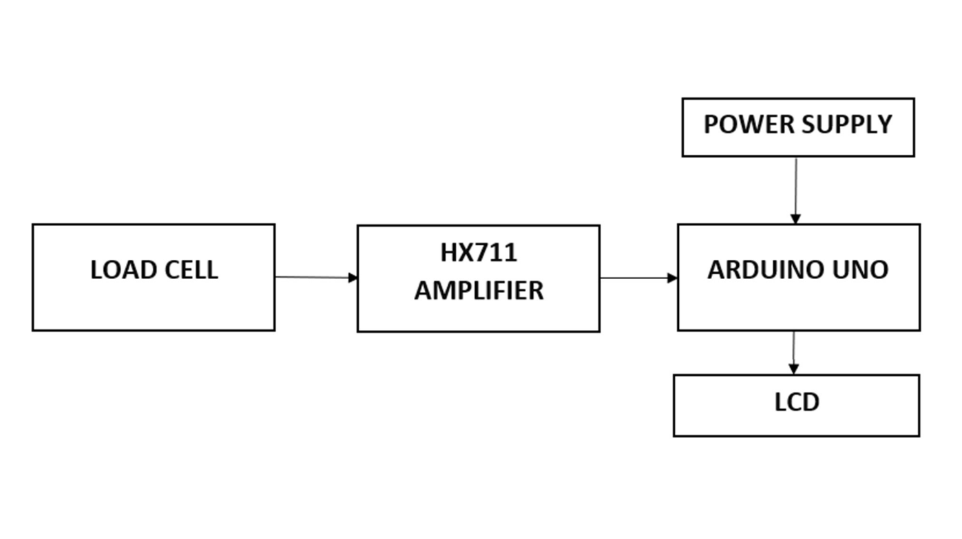

Figure 3.1.1 Block Diagram for Self-Weighing System

As seen in figure 3.1.1, the system consists of a weight determining sensor, an amplifier, a microcontroller, and an LCD to display the weight.

Load cell (Aluminum Block) is a transducer that transforms force or pressure into electrical output. A load cell usually consists of four strain gaugesin a Wheatstone bridge configuration. The magnitude of the electrical output is directly proportional to the force being applied. Strain gauges in the Load Cell, deform when pressure is applied to it. And then strain gauge generates an electrical signal on deformation as its effective resistance changes on deformation. As seen in Figure 3.1.3, in the load cell, the resistors are placed with strain gauges and alternating tension and compression formation. When force is exerted on the load cell, the structure and resistance will change and output voltage, V0 is calculated using [6]
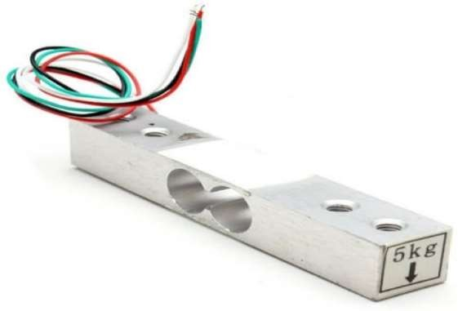
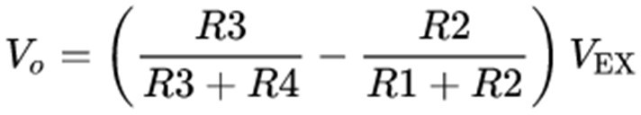 Equation 3.1

Figure 3.1.2 Load Cell

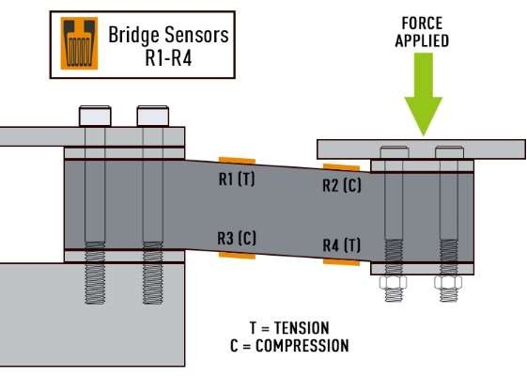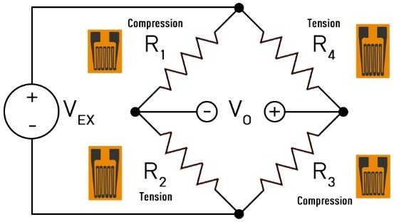
Wheatstone Bridge

Figure 3.1.3 Composition of Load Cell
Electrical signals generated by the Load cell are in few millivolts, so they need to be further amplified by some amplifier and hence HX711 Weighing Sensor comes into the picture. HX711 Weighing Sensor Module has HX711 chip, which is a 24 high precision A/D converter [7], the load cell is connected to it as shown in 3.1.1.
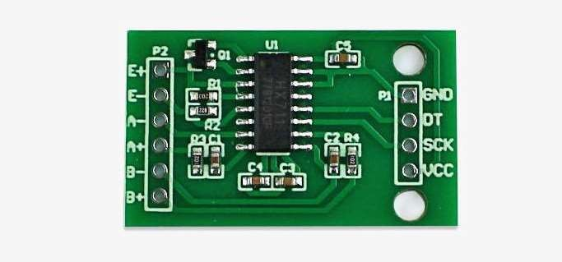

Figure 3.1.4 HX711 Amplifier

Then this amplified value is fed to the Arduino. Now Arduino calculates the output of HX711 and converts that into the weight values in grams/kilograms and it is shown on the LCD

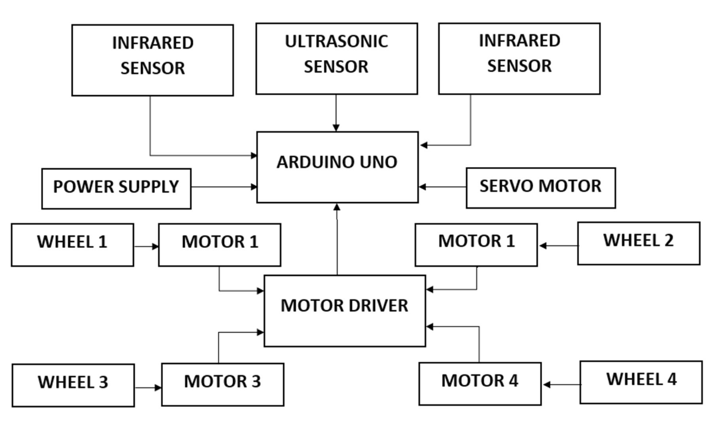

Figure 3.1.5 Block Diagram for Automatic Follow System

As seen is figure 3.1.2, the Sensors used in the system are Ultrasonic Sensor and Infrared Sensor.
An Ultrasonic Sensor is an instrument that measures the distance to an object using ultrasonic sound waves. It uses a transducer to send and receive ultrasonic pulses that relay back information about an object’s proximity. High-frequency sound waves reflect from boundaries to produce distinct echo patterns. This Sensor helps in finding the distance between the user and the suitcase so that it the system can maintain a safe distance between the two.
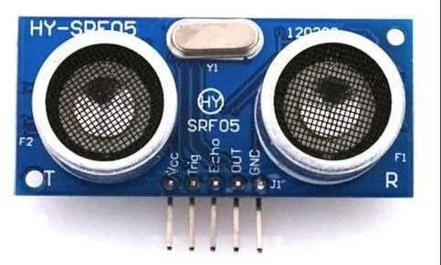

Figure 3.1.6 Ultrasonic Sensor

An Infrared Sensor is an electronic device, that emits the light in order to sense some object of the surroundings. An IR sensor can measure the heat of an object as well as detects the motion. Usually, in the infrared spectrum, all the objects radiate some form of thermal radiation. These types of radiations are invisible to our eyes, but infrared sensor can detect these radiations. The emitter is simply an IR LED and the detector is simply an IR photodiode . Photodiode is sensitive to IR light of the same wavelength which is emitted by the IR LED. When IR light falls on the photodiode, the resistances and the output voltages will change in proportion to the magnitude of the IR light received. This Sensor is used to detect the movement of the user in order to control the direction and corresponding path taken by the suitcase.

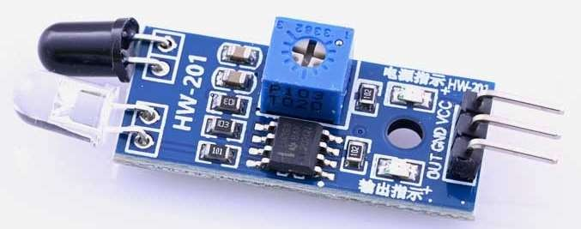

Figure 3.1.7 Infrared Sensor

The Ultrasonic Sensor and the Infrared Sensor can be used to detect and avoid obstacles on the path of the suitcase as well.

The motors used in the system as seen from Figure 3.1.2 include the DC Motor along with the Motor Driver.

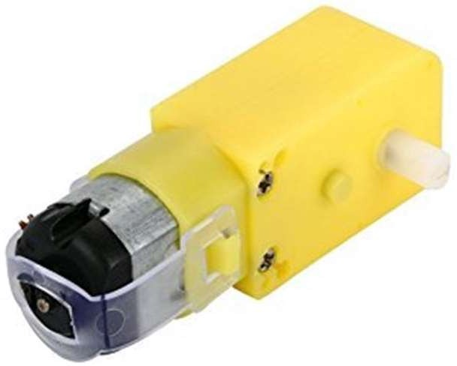

Figure 3.1.8 DC Battery Operated Motor

A motor driver showcases itself as an interface between the motor and the microcontroller. The reason is that the microcontroller and the motor work on different ranges of voltages. The engine will use up a higher current level than the microcontroller. A motor driver module is required when connecting two devices that operate under different current levels to a power supply voltage. In this case, a motor acts as a third device that steps up or steps down the voltage supply. The majority of motor drivers in the market now are in the form of ICs.
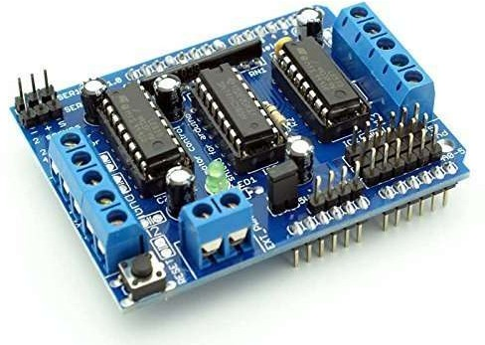
Figure 3.1.9 Motor Driver

  - Flow Chart Of Working Model

START
CONNECT ARDUINO AND LOAD CELL

CALIBRATE LOAD CELL
GET CALIBRATION FACTOR

WEIGHT DOES NOT MATCH

CONNECT TO AMPLIFIER

PLACE DIFFERENT WEIGHTS ON THE CELL

VERIFY WITH ACTUAL WEIGHTS

WEIGHT MATCHES

END

USE THE SYSTEM AS A WEIGHING SCALE
Figure 3.2.1 Flowchart for The Self Weighing System

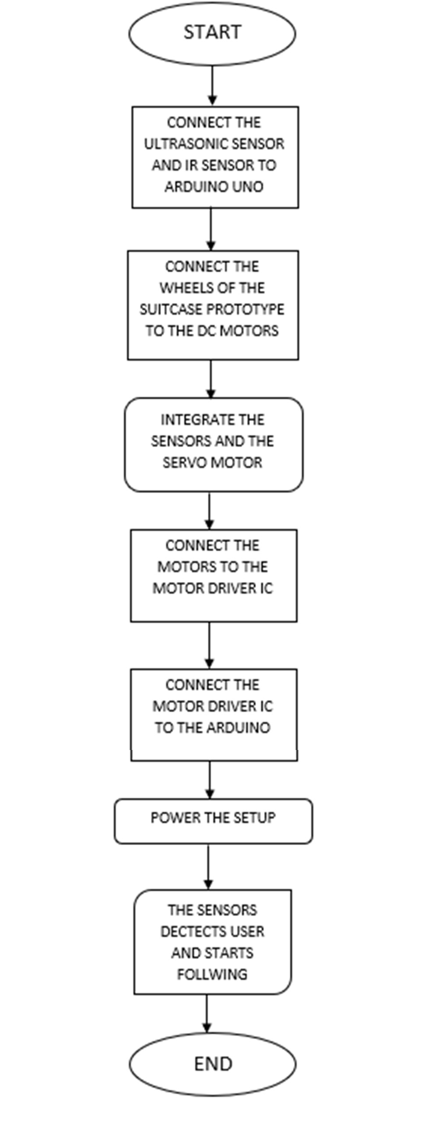

Figure 3.2.2 Flowchart For Automatic Follow System

Chapter 4: Result

Result

Weighing System:
The LCD displays the rounded average of 10 values given by the load cell corresponding to the given weight
The weight is displayed in grams and kilograms as shown in fig 4.2.1 and 4.2.2 Setup:
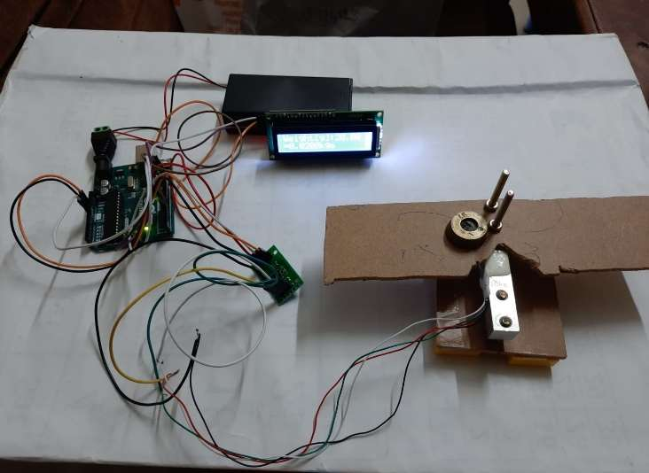
HX711 Amplifier
Load Cell
Arduino
LCD

Figure 4.2.1 Weighing Scale Setup
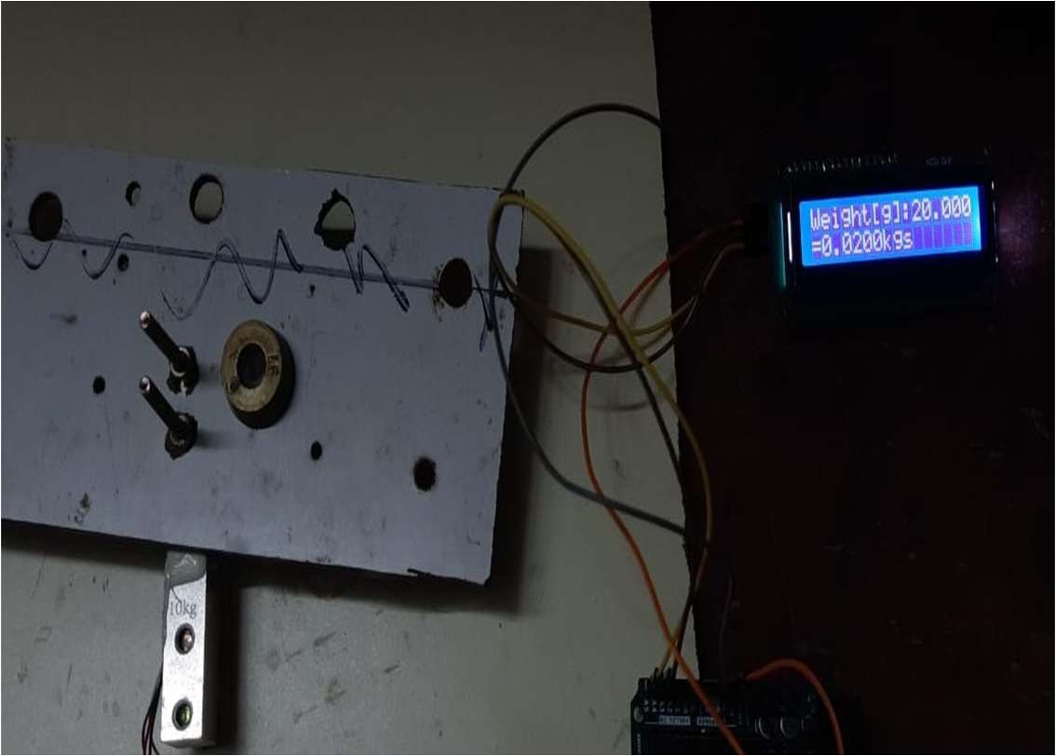
    - 20g stone weighed and weight is displayed on LCD

Figure 4.2.1 Weighing System Displaying Weight of 20g Stone

    - Battery (36g) weighed and weight is displayed on LCD
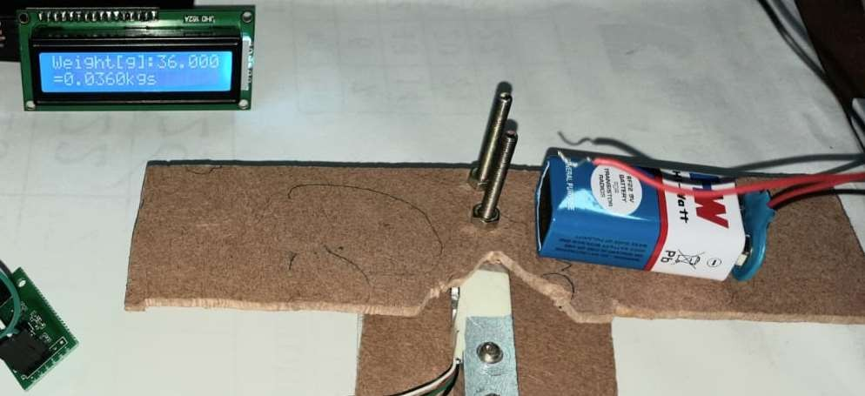
Figure 4.2.2 Weighing System Displaying Weight of 36g Batte

Automatic Follow System:

Condition | Movement of the Suitcase
If distance>15 and distance<20
Right IR Sensor=1 & Left IR Sensor=1 | Forward
Right IR Sensor=0 & Left IR Sensor=1 | Left
Right IR Sensor=1 & Left IR Sensor=0 | Right
If distance<15 and distance>5
Right IR Sensor=0 & Left IR Sensor=1 | Top Right
Right IR Sensor=1 & Left IR Sensor=0 | Top Left
Right IR Sensor=1 & Left IR Sensor=1 | Bottom Right; Bottom Left
If distance<5 | Stop

Table 4.2 Movement of Suitcase based on presence of Obstacle on the path

Distance refers to the distance between the suitcase and the obstacle and the Right IR sensor and Left IR Sensor detect obstacle on the left and right side of the suitcase

Method
The suitcase has been designed to realize a weighing setup for which the system has integrated the load cell and the HX711 amplifier module. The calibration factor has been determined and used to get accurate values of the weight of the suitcase. The Load Cell Setup is integrated with the Arduino and the weight measured by the system is displayed to the user with the help of the Liquid Crystal Display.

The Automatic Follow Setup has been designed by making use of the Ultrasonic sensors and Infrared Sensors. The Ultrasonic sensor is used to find the distance between the user and the suitcase and to find the distance between the suitcase and the obstacles on the path. The Infrared Sensors are used to detect the movement or presence of objects on the side of the suitcase and the suitcase is optimized to avoid the obstacles using the same. The speed of the suitcase is maintained using the Motor driver which makes use of battery-operated DC motors.

Conclusion
The system has been successfully designed and illustrated to weigh a suitcase automatically without having to use the traditional weighing scales. The weight sensors are used for weighing things and displaying the result through the LCD which acts as a user interface. The system is also capable of following the user efficiently on a flat terrain considering a less crowded setup. This is done by making use of IR Sensors, Ultrasonic Sensors, and a set of motors for speed control. Hence, the above model is considered as an efficient method for weighing luggage hassle free without having to struggle at the airport to check if your baggage is over-weight and helps the user by following him/her around without having to drag the luggage around the place.

References

- P. Wang, T. Zhang and S. Wang, "Remote Control and Tracking Dual Mode Smart Suitcas," 2018 3rd International Conference on Robotics andAutomation Engineering (ICRAE), 2018, pp. 117-121L.

- Belsito, M. Ferri, L. Masini and A. Roncaglia, "Development of Weighing Systems with Improved Dynamic Range Using High-Resolution Resonant MEMS Strain Sensors," 2021 21st International Conference on Solid-StateSensors, Actuators and Microsystems (Transducers), 2021, pp. 1331-1334

- S. Jaiteh, S. F. Adillah Suhaimi, T. Ching Seong, A. M. Buhari, L. Liniand H. Neyaz, "Smart Scale Tracking System Using Calibrated Load Cells," 2019 IEEE Conference on Sustainable Utilization and Development in Engineering and Technologies (CSUDET), 2019, pp. 170-174, doi: 10.1109/CSUDET47057.2019.9214692.

- M. Derkach, D. Matiuk and I. Skarga-Bandurova, "Obstacle Avoidance Algorithm for Small Autonomous Mobile Robot Equipped with Ultrasonic Sensors," 2020 IEEE 11th International Conference on Dependable Systems, Services and Technologies (DESSERT), 2020, pp.236-241

- O. B. Samin, H. Sohail, M. Omar and H. Hummam, "Accelerometer and Magnetometer Enabled Entity Following Automated Suitcase," 2020 International Conference on Emerging Trends in Smart Technologies(ICETST), 2020, pp. 1-5

- P. L. S. Krishnan, R. Valli, R. Priya and V. Pravin Kumar, "Smart Luggage Carrier system with Theft Prevention and Real Time Tracking Using Nano Arduino structure," 2020 International Conference on System, Computation, Automation and Networking (ICSCAN), 2020

Appendix
Appendix-A
Load cell specifications

The electrical, physical, and environmental specifications of a load cell help to determine which applications it is appropriate for. Common specifications include:

Specification | Justification
Full Scale Output (FSO) | Electronic output expressed in mV/V. Measured at full scale.
Combined Error | percent of the full scale output that represents the maximum deviation from the straight line drawn between no load and load at rated capacity. Often  measured during decreasing and increasing loads
Non-Linearity | - The maximum deviation of the calibration curve from a straight line drawn between the rated capacity and zero load. Measured on increasing load and expressed as percent of full scale output.
Hysteresis | Maximum difference between load cell output signals for the same applied load. The first measurement can be obtained by decreasing the  load from rated output and the second by increasing the load from zero.
Repeatability | Maximum difference between output measurements for repeated loads under identical  conditions. Measured in percent of rated output
Zero Balance (Offset) | Output reading of the load cell with rated excitation under no load. The deviation in output between a true zero measurement and a real load cell under zero load expressed as a percentage of  full scale output.
Compensated Temperate Range | The temperature range over which a load cell is compensated so that it can ensure zero balance & rated output within specified limits. Expressed as  °F or °C.
Operating Temperature Range | Temperature range extremes in which a load cell can operate without permanent, adverse effects on  any of its performance characteristics. Expressed as °F or °C
Temperature Effect on Output | Modification of output readings caused by load cell temperature. Expressed as percent of full scale output per degree of °F or °C.
Input Resistance | Input resistance of the load cell's bridge circuit.  Measured at the positive & negative excitation leads with no load applied. Measured in Ohms
Output Resistance | Output resistance of the load cell's bridge circuit.  Measured at the positive & negative excitation leads with no load applied. Measured in Ohms
Safe Overload | The maximum load that can be applied to a load cell without causing permanent effects to its performance specifications. Measured as a  percent of full scale output.
Material | Substance that comprises the spring element of the load cell

Appendix-B

Source Code for Load Cell

#include <LiquidCrystal_I2C.h> LiquidCrystal_I2C lcd(0x27, 16,2); #include "HX711.h"
HX711 scale(6, 7);
float calibration_factor = -212; // this calibration factor is adjusted according to my load cell float units;

void setup() { Serial.begin(9600); lcd.begin();
lcd.clear(); lcd.backlight();
lcd.print( "WEIGHT SCALE" ); scale.set_scale();
scale.tare(); //Reset the scale to 0
}
void loop() {
scale.set_scale(calibration_factor); //Adjust to this calibration factor Serial.print("Reading: ");
units = scale.get_units(), 10; if (units < 0)
{
units = 0.00;
}

Serial.print(units); Serial.print(" grams");
Serial.print(" calibration_factor: "); Serial.print(calibration_factor); Serial.println();
int sum=0; float avg; if(units>0)
{
for(int i=0;i<10;i++)
{
sum=sum+units;
}
avg=sum/10; Serial.print("avg="); Serial.print(avg); lcd.setCursor(0,0); lcd.print("Weight[g]: "); lcd.setCursor(10,0);
lcd.print(avg); //displays the weight in 4 decimal places only for calibration

lcd.setCursor(0,1); lcd.print("="); lcd.setCursor(1,1); lcd.print(avg/1000,4); lcd.setCursor(7,1); lcd.print("kgs"); delay(100);
}
else
{
lcd.setCursor(0,0); lcd.print("Weight[g]:0.00"); lcd.setCursor(0,1); lcd.print("="); lcd.setCursor(1,1); lcd.print("0.000kgs"); delay(50);
}
}

Source Code for Automatic Follow System #include<AFMotor.h>
#define RIGHT A2 // Right IR sensor connected to analog pin A2 of Arduino Uno #define LEFT A3 // Left IR sensor connected to analog pin A3 of Arduino Uno #define trigPin A4 // Trigger pin connected to analog pin A1 of Arduino Uno #define echoPin A5 // Echo pin connected to analog pin A0 of Arduino Uno unsigned int Right_Value = 0; //Variable to store Right IR sensor value
unsigned int Left_Value = 0; //Variable to store Left IR sensor value int Speeed=165;

//create motor objects
AF_DCMotor motor1(1,MOTOR12_1KHZ); AF_DCMotor motor2(2,MOTOR12_1KHZ); AF_DCMotor motor3(3,MOTOR34_1KHZ); AF_DCMotor motor4(4,MOTOR34_1KHZ);

void setup()
{
Serial.begin(9600); //initailize serial communication at 9600 bits per second: pinMode(trigPin, OUTPUT);
pinMode(echoPin, INPUT);
pinMode(RIGHT, INPUT); //set analog pin RIGHT as an input: pinMode(LEFT, INPUT); //set analog pin RIGHT as an input:
}

void loop()
{
long duration, distance; digitalWrite(trigPin, LOW); delayMicroseconds(2); digitalWrite(trigPin, HIGH); delayMicroseconds(10);

digitalWrite(trigPin, LOW); duration = pulseIn(echoPin, HIGH);
distance = (duration/2) / 29.1; // speed of sound =34cm/sec Serial.print("distance");
Serial.print(distance); Serial.println(" cm");
Right_Value = digitalRead(RIGHT); Left_Value = digitalRead(LEFT); Serial.print("RIGHT"); Serial.println(Right_Value); Serial.print("LEFT"); Serial.println(Left_Value);

if((distance<10&&distance>20)||(Right_Value=='0'&&Left_Value=='0'))
{
Stop();
}
if(distance>10&&distance<=15)
{
if(Right_Value=='0'&&Left_Value=='1') left(); if(Right_Value=='1'&&Left_Value=='0') right(); if(Right_Value=='1'&&Left_Value=='1')
{
bottomright(); bottomleft();
}
}
if(distance>15&&distance<20)
{
if(Right_Value=='1'&&Left_Value=='1') forward(); if(Right_Value=='0'&&Left_Value=='1') topleft(); if(Right_Value=='1'&&Left_Value=='0') topright();
}
}

void forward()
{
motor1.setSpeed(Speeed); motor1.run(BACKWARD); motor2.setSpeed(Speeed); motor2.run(BACKWARD); motor3.setSpeed(Speeed); motor3.run(FORWARD); motor4.setSpeed(Speeed); motor4.run(FORWARD);
}
void back()
{
motor1.setSpeed(Speeed); motor1.run(FORWARD);

motor2.run(FORWARD); motor3.setSpeed(Speeed); motor3.run(BACKWARD); motor4.setSpeed(Speeed); motor4.run(BACKWARD);
}
void left()
{
motor1.setSpeed(Speeed); motor1.run(BACKWARD); motor2.setSpeed(Speeed/1.5); motor2.run(BACKWARD); motor3.setSpeed(Speeed/1.5); motor3.run(BACKWARD); motor4.setSpeed(Speeed); motor4.run(BACKWARD);
}
void right()
{
motor1.setSpeed(Speeed/1.5); motor1.run(BACKWARD); motor2.setSpeed(Speeed); motor2.run(BACKWARD); motor3.setSpeed(Speeed); motor3.run(BACKWARD); motor4.setSpeed(Speeed/1.5); motor4.run(BACKWARD);
}
void topleft(){ motor1.setSpeed(Speeed/1.5); motor1.run(FORWARD); motor2.setSpeed(Speeed/1.5); motor2.run(FORWARD); motor3.setSpeed(Speeed); motor3.run(FORWARD); motor4.setSpeed(Speeed); motor4.run(FORWARD);
}
void topright(){ motor1.setSpeed(Speeed); motor1.run(BACKWARD); motor2.setSpeed(Speeed); motor2.run(BACKWARD); motor3.setSpeed(Speeed/1.5); motor3.run(FORWARD); motor4.setSpeed(Speeed/1.5); motor4.run(FORWARD);
}
void bottomleft()
{
motor1.setSpeed(Speeed/1.5); motor1.run(FORWARD); motor2.setSpeed(Speeed/1.5); motor2.run(FORWARD);

motor3.run(BACKWARD); motor4.setSpeed(Speeed); motor4.run(BACKWARD);
}
void bottomright()
{
motor1.setSpeed(Speeed); motor1.run(FORWARD); motor2.setSpeed(Speeed); motor2.run(FORWARD); motor3.setSpeed(Speeed/1.5); motor3.run(BACKWARD); motor4.setSpeed(Speeed/1.5); motor4.run(BACKWARD);
}
void Stop()
{
motor1.setSpeed(0); motor1.run(RELEASE); motor2.setSpeed(0); motor2.run(RELEASE); motor3.setSpeed(0); motor3.run(RELEASE); motor4.setSpeed(0); motor4.run(RELEASE);
}

